28.15: a) 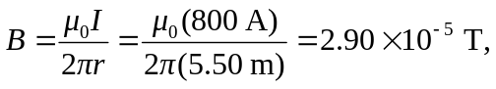 to the east.
b) Since the magnitude of the earth’s magnetic filed is 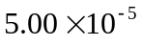 T, to the north, the total magnetic field is now 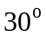 east of north with a magnitude of 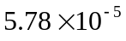 T. This could be a problem!

